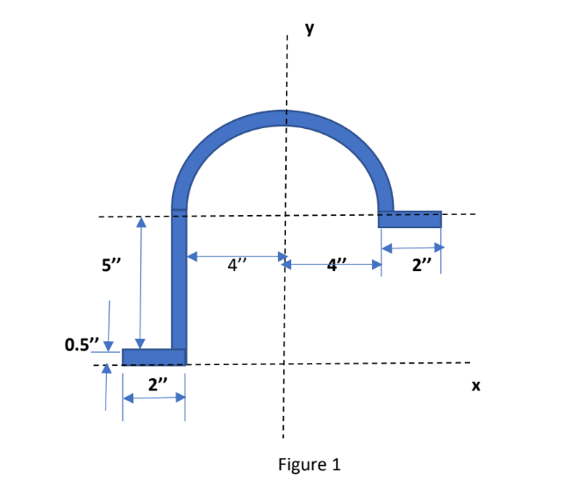1.



Let O be the origin (0,0).

We split the area into 4 regions:

ABCD (Region 1), ECFG (Region 2), FGHI (Region 3) and HJKL (Region 4)

We know,

**XCM (Total area) = (ΣI=14 XCM(Region i)x Area(Region i))/ (ΣI=14 Area(Region i))**

**YCM (Total area) = (ΣI=14 YCM(Region i)x Area(Region i))/ (ΣI=14 Area(Region i))**

**Region 1:**

**XCM** = -4-(2/2) = -5”

**YCM** = 0.5/2 = 0.25”

**Area** = 2x0.5 = 1 sq.inch

**Region 2:**

**XCM** = -4-(0.5/2) = -4.25”

**YCM** = 0.5 + 2.5 = 3”

**Area** = 5x0.5 = 2.5 sq.inch

**Region 3:**

**XCM** = 0

**YCM** –

We take semi-circular elements of infinitesimal area dA = πrdr (r ranging from 4” to 4.5”)

∴YCM = (∫4 4.5 ydA)/(Area) = (∫4 4.5 (2r/π)( πrdr))/13.352

= 18.0833/6.675 = 2.709”

From origin, YCM = 5.5 + 2.709 = 8.209”

**Area** = (π(4+0.5)2 - π(4)2)

= 6.675 sq.inch

**Region 4:**

**XCM** = 4 + (2/2) = 5”

**YCM** = 5.5 – (0.5/2) = 5.25”

**Area** = 2x0.5 = 1 sq.inch

XCM of the entire area = ((-5)(1) + (-4.25)(2.5) + 0 + (5)(1))/(1+2.5+6.675+1)

= -10.625/11.175

**= -0.9508”**

YCM of the entire area = ((0.25)(1)+(3)(2.5)+(8.209)(6.675)+(5.25)(1))/11.175

**= 6.066”**

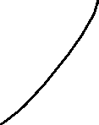

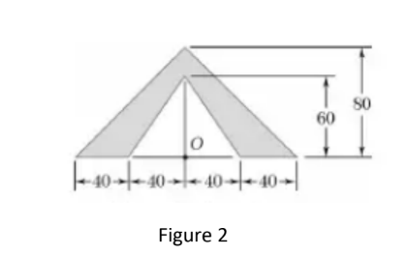

2.

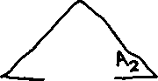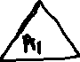

(a)

A3­ = A1 + A2 (Entire triangle)

We know **IA1(about O) + IA2(about O) = IA3(about O)**

IA (A being any isosceles triangle of base = b and height = h):

**Ix (taking centroid as origin) = bh3/36**

**Iy (taking centroid as origin) = hb3/48**

**∴I (about origin) = Ix + Iy = bh/12(h2/3 + b2/4) [Perpendicular Axis Theorem]**

**We know the center of mass of an isosceles triangle lies at h/3**

**∴ I (about base center) = I (about origin) + bh/2(h/3)2 [Parallel Axis Theorem]**

**= bh(b2 + 4h2)/48**

IA1 (b = 80, h = 60) = 80x60x((80)2 + 4(60)2)/48

= **2080000**

IA3 (b = 160, h = 80) = 160x80x((160)2 + 4(80)2)/48

= **13653333.3333**

∴IA2 = 13653333.3333 – 2080000 = 11573333.3333 mm4 = **1157.333 cm4**

(b)We know that A1Xcm(1) + A2Xcm(2) = A3Xcm(3)­.

Similarly, A1Ycm(1) + A2Ycm(2) = A3Ycm(3)­

Xcm(1) = XCM(3) = 0 (Symmetry)

∴XCM(2) = 0

YCM(1) = h1/3 = 60/3 (from O)

= **20**

YCM(3) = h3/3 = 80/3 (from O)

= **26.66**

A1 = (80)(60)/2 = 2400

A3 = (160)(80)/2 = 6400

A2 = A3 – A1 = 4000

∴YCM(2) = (A3Ycm(3) - A1Ycm(1))/A2

= **30.666 mm** (from O)

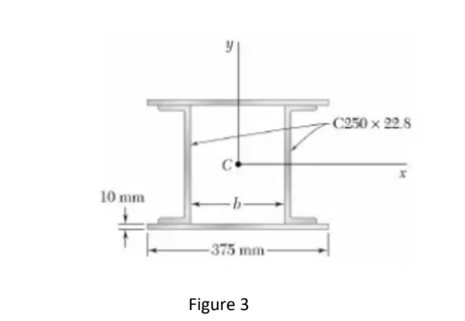

3.

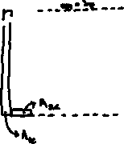

First, we will calculate IX:

Ix of one plate = Apbp2/12 + Ap(d+bp/2)2

= (37.5)(1)2/12 + (37.5)(13.2)2

= **6537.125 cm4**

∴IX of both plates = 2x6537.125 = **13074.25 cm4**

IX of one C-Section = IX(of A1C) + 2IX(of A2C)

∴IX of both C-Sections = 2IX(of A1C) + 4IX(of A2C) [Due to symmetry]

= 2(A1Clc2/12) + 4(A2Cwc2/12 + A2C((lc-wc)/2)2)

= 2(15.494x25.42/12) + 4(3.5929(0.612/12 + 12.3952))

= 1666.018 + 2208.441

= **3874.4591 cm4**

IX of entire section = 13074.25 + 3874.4591

= **16948.7091** **cm4**

Total Area of section = 2x(AP + AC) = 2(37.5 + 22.6798) =

Radius of gyration about X axis = (IX/Total Area)0.5

= (16948.7092/120.3596)0.5

= **11.8666 cm**

Now we will calculate IY:

IY of one plate = APlp2/12

= 37.5x(37.5)2/12

= 4394.53125 cm4

∴IY of both plates = 2x4394.53125

= **8789.0625 cm4**

IY of one C-Section = IY(of A1C) + 2IY(of A2C)

∴IY of both C-Sections = 2IY(of A1C) + 4IY(of A2C) [Due to symmetry]

= A

IY of entire section = 8789.0625 + 11648.0488SS

= **20437.1113 cm4**

The radius of Gyration about Y-axis = (IY/Total Area)0.5

= (20437.1113/133)0.5

= **12.396 cm**

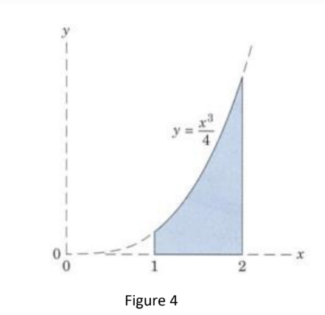4.

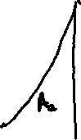

Area of figure = ∫1 2dA = ∫1 2 ydx = (∫1 2 x3dx)/4

= (24 – 14)/16

= 15/16 mm2

= **0.9375 mm2**

Iy = ∫1 2 x2dA (dA = ydx)

= ∫1 2 x2ydx

= ∫1 2 x2(x3/4)dx

= ( ∫1 2 x5dx)/4

= 1/24(26 – 16)

= 63/24 = 21/8

= **2.625 mm4**

∴Rectangular radius of gyration (rY) about this axis = (IY/A)0.5

= ((21/8)/(15/16))0.5

= 2.80.5

= **1.6733 mm**

Ix = IA1(about X) + IA2(about X)

IA1(about X) = ∫00.25  y2dA (dA = 1dy)

= ∫00.25  y2dy

= 1/(64x3)

IA2(about X) = ∫0.252  y2dA (dA = (2-x)dy = (2-41/3y1/3)dy)

= 2∫0.252  y2dy - 22/3∫0.252y7/3dy

= 2/3(8 – 1/64) – 3.22/3(210/3 – 2-20/3)/10

= 16/3 – 2/(64x3) – 3(24 – 2-6)/10

Ix = 1/(64x3) + 16/3 – 2/(64x3) – 3(16 - 1/64)/10

= (16 - 1/64)/3 – 3(16 - 1/64)/10

= (1/3 – 3/10) x (16 – 1/64)

= (1/30) x (16 – 1/64)

= **0.5328125 mm4**

∴Rectangular radius of gyration (rX) about this axis = (IX/A)0.5

= (0.5328125/0.9375)0.5

= (0.568333)0.5

= 0.75387 mm

